The Peabody Rotary Sam Berns Scholarship Application 2018

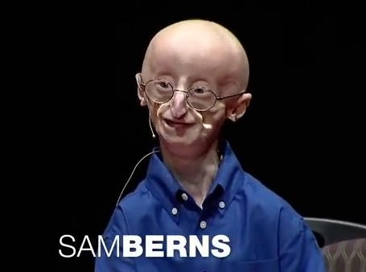
Rotary is an international charitable organization comprised of professional and business leaders whose goals are humanitarian service, high ethical standards and the promotion of goodwill and peace around the world. The Peabody Rotary Club has served the City of Peabody since it was officially chartered in 1920.

The Rotary Club of Peabody awards Scholarships to seniors in high school who are residents of Peabody and who exemplify the Rotary Motto of “Service above Self”. The Sam Berns scholarship was created in 2014, in honor of a young man who exemplified courage and integrity in the face of the challenges of Progeria, and whose "can do" attitude and positive outlook on life have inspired millions to live life to its fullest. Sam, who passed away in January 2014 at the age of 17, was the inspiration behind the creation of the Peabody-based Progeria Research Foundation, whose mission is to find a cure for Progeria. Progeria is a rare, rapid aging disease that afflicts children, who die of heart disease at an average age of 14 years.

Eligibility Requirements

Applicant must be a Peabody Resident, and graduating senior of an accredited public, private, parochial, vocational or charter high school. They must be accepted to an accredited institution of higher education or vocational training program. They must be able to demonstrate that they reach out to others through community service either locally, regionally or internationally, and exemplify the qualities that Sam practiced daily.

Application Process

The Application can be found on line at www.rotarypeabody.org
This application will also be available through the high school guidance department.

Required:
- Applicant Information
- Parent/Guardian Information
- Answer application questions and essay on separate sheets, preferably typed.
- Official transcripts from High School
- Interviews for application finalists

Note:
- Incomplete applications will not be considered.
- No applications will be considered after the due date: APRIL 7, 2018.
Mail the completed application on or before April 7, 2018 (MUST be postmarked by this date) to: Peabody Rotary Scholarship Fund, c/o Audrey Gordon; P.O. Box 94 Peabody MA 01960

Applicant Information:

Full Name: _____________________________________________________

Date of Graduation: ______________________________________________

Address: _______________________________________________________

City, State, Zip Code: ____________________________________________

Telephone: _____________________ Cell Phone: ______________________

E Mail Address: _________________________________________________

Colleges/ University accepted to: ____________________________________

______________________________________________________________

I certify that I am a resident of Peabody Massachusetts.

_______________________________________ ____________________
Signature Date

Parent/ Guardian Information:

Name: ________________________________________________________

Address:_______________________________________________________

City, State, Zip Code: ____________________________________________

Telephone: ______________________ Cell Phone: _____________________

E Mail Address: _________________________________________________

I certify that we are residents of Peabody Massachusetts.

______________________________________ ____________________
Parent Signature Date

Application for Peabody Rotary’s Sam Berns Scholarship:

1. After watching Sam’s TEDx talk, https://www.youtube.com/watch?v=36m1o-tM05g, choose your favorite Sam philosophy and explain why you chose it:
1. Be okay with what you can’t do, because there’s so much you can do
2. Surround yourself with people you want to be with
3. Keep moving forward
4. Never miss a party if you can help it

2. What is your philosophy for a happy life?

3. What is your favorite quote from the talk, and why?

4. What obstacles have you overcome, and how? How did your life change after overcoming these obstacles?

- Explain the most meaningful way in which you have helped others through community service. This could be locally, regionally, or internationally.

6. Include a brief essay explaining why you think you are deserving of the Sam Berns Rotary Scholarship

